Installation notes for Anemometer Converter Unit
This circuit is available in this github repository :
https://github.com/re-innovation/AnemometerConverter

It is designed for use with anemometer NRG #40C. The datasheet for this is available here:
https://www.nrgsystems.com/products/met-sensors/anemometers/detail/40c-anemometer

The output from the anemometer is a sine wave with a frequency propotional to the wind speed. The output amplitude varies from 80mV to 12V, depedning upon the wind speed.

The converter schematic is here:
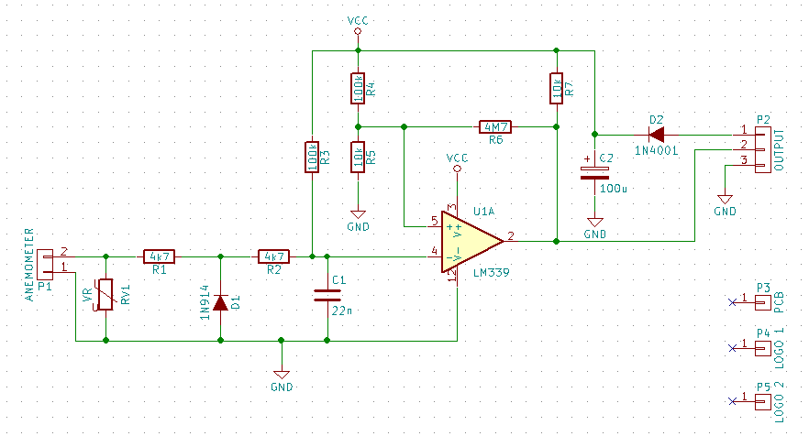

Wiring Information

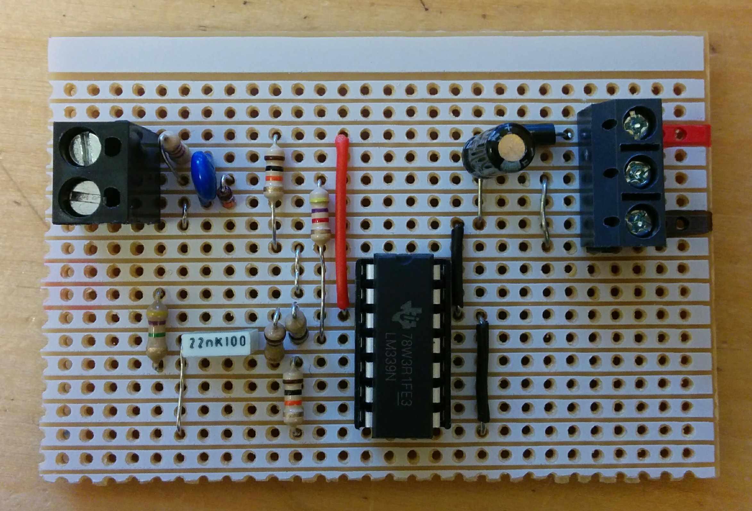
Anemometer Input
Anemometer Input

+Vcc (3.3-12V)

DATA OUTPUT

IN 1
IN 2

GROUND

The Input voltage can be from 3.3V DC to 12 V DC. Designed for 3.3 to 5V working powered from the datalogger.

The DATA OUTPUT gives a digital frequency output switching from 0 to Vcc at a frequency proportional to the anemometer rotational speed. This output is normally high (if the anemometer is not spinning) and goes low to indicate a pulse.

